Requirement Analysis
Technology Stack & Technical Architecture
Date | 02 October 2026
Student Name | Dhanyaa V S
Project Name | Automated Network Request Management in ServiceNow

1. Technical Architecture Overview
The solution leverages the enterprise ServiceNow cloud platform architecture. End-user interactions occur via the modern Service Portal (/sp) executing client-side dynamic UI policies. Transactional requests trigger native Flow Designer automation, which interfaces directly with the relational database layer (Database Tables - u_database_table), manages approval lifecycles (sysapproval_approver), and orchestrates automated SMTP email notifications.

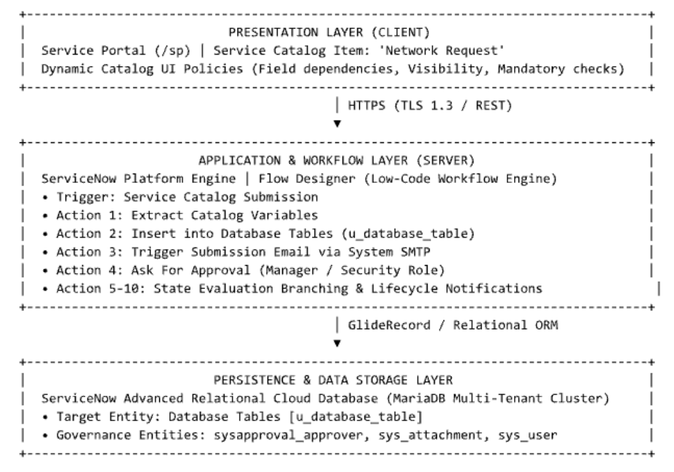
2. Table-1: Components & Technologies
S.No | Component | Description | Technology / Specification
1 | User Interface (UI) | Portal interface for browsing catalog items, submitting connection parameters, and viewing request statuses[cite: 1, 7]. | ServiceNow Service Portal (/sp), AngularJS, HTML5, CSS3, Bootstrap
2 | Client-Side Application Logic | Dynamic validation and conditional field rendering (e.g., displaying Existing ID when Type of Connection is Existing)[cite: 1, 7]. | ServiceNow Catalog UI Policies, Catalog Client Scripts (JavaScript ECMAScript 2021)
3 | Server-Side Workflow Engine | Asynchronous workflow engine that parses submitted variables, provisions database entries, and controls process routing[cite: 2, 7]. | ServiceNow Flow Designer
4 | Approval Management Service | Governance engine dispatching approval records to designated managers and capturing decisions[cite: 2, 7]. | ServiceNow Approval Engine, sysapproval_approver relationship table
5 | Relational Database | Custom schema with auto-numbering to store request specifications, payment details, and approval states[cite: 2, 7]. | Custom ServiceNow Table: Database Tables (u_database_table)[cite: 2, 7]
6 | Cloud Platform Database | Underlying high-availability relational cluster supporting the ServiceNow instance. | ServiceNow Advanced Cloud Relational Database (MariaDB Multi-Tenant Cluster)
7 | File & Attachment Storage | Secure repository for uploading and referencing network diagrams, site layouts, or ID proofs[cite: 1, 7]. | ServiceNow Attachment Engine (sys_attachment, sys_attachment_doc)
8 | Outbound Notification Service | System mailer delivering real-time lifecycle notifications (submission confirmation, approvals, and rejections)[cite: 2, 7]. | ServiceNow Email Engine (System Mailer), Outbound SMTP
9 | Identity & Directory Service | Directory lookups for verifying user identities, contact fields, and hierarchical manager approvals[cite: 1, 2, 7]. | ServiceNow User Administration (sys_user), LDAP/SSO Integration, RBAC
10 | Infrastructure & Hosting | Cloud-hosted platform environment supporting catalog rendering and automated flow execution. | ServiceNow Enterprise Cloud Infrastructure / Personal Developer Instance (PDI)

Table-2: Application Characteristics
S.No | Characteristics | Description | Technology / Architectural Justification
1 | Open-Source & Platform Frameworks | Core front-end and web frameworks used to construct responsive catalog forms and interactive widgets. | AngularJS, Bootstrap 3.x, HTML5, JavaScript (ECMAScript 5 & modern Glide APIs)
2 | Security Implementations | Access controls, encrypted data transport, and role-based field restrictions. | TLS 1.3 in-transit encryption, AES-256 at-rest database encryption, ServiceNow Access Control Lists (ACLs on u_database_table)
3 | Scalable Architecture | Tiered architecture isolating user portal rendering, workflow automation, and relational data operations. | ServiceNow Multi-Instance Architecture; asynchronous Flow Designer execution queue preventing thread blocking
4 | Availability & Resiliency | Redundant infrastructure minimizing service downtime during catalog processing. | Advanced High Availability (AHA) multi-datacenter pairing, automatic failover clustering
5 | Performance Optimization | Low latency form interactions and fast record creation. | Platform in-memory caching, CDN edge delivery for static UI assets, indexed database keys, and client-side UI Policies avoiding excessive server calls

